Cryptography

Project: CryptoBench

Jamie Dempsey – C00295144@setu.ie

https://github.com/C00295144/Cryptography.git

Introduction
This experiment evaluates the performance of several cryptographic algorithms across key generation, encryption, decryption, digital signing, and verification. The goal of this experiment is to compare symmetric and asymmetric techniques, including RSA, DSA, ECC, AES, and ChaCha20, and to measure how processing time changes with different security strengths. All tests were run in a Python environment within Visual Studio Code.
The experiments were completed on a machine running Windows 11. The system is equipped with an AMD Ryzen 5 3600X 6-Core Processor (3.80 GHz) and 16 GB of RAM.
All tests were run in Python 3.14.0 using the cryptography package (v 43.0.0). The code was executed using CPython on a Windows terminal environment. Each measurement was repeated ten times, with the first run being discarded to improve accuracy. The remaining nine results were taken and averaged to create the final figure for the results.
Random input data for encryption, decryption, and digital signing was generated using os.urandom() to provide all experiments with unbiased data. Each algorithm was tested using the recommended secure settings from the Python cryptography library. RSA encryption used OAEP padding, and RSA signing used PSS padding. AES ran in CBC mode with proper PKCS-style padding to handle block alignment. DSA and RSA signatures were created using the SHA-256 hash function, and ECC signing used the ECDSA algorithm.

Results & Analysis
This section presents the performance measurements for each cryptographic algorithm.

Key Pair Generation Results
This graph shows the expense of generating public key pairs across RSA, DSA and ECC. RSA grows significantly over the course of each key size increase, reaching close to a minute in total at 265-bit security. DSA also increases, but remains below RSA. ECC is consistently the fastest across all three, staying under 2ms even at the highest security.

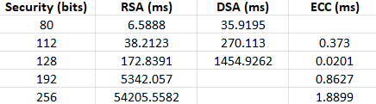

Encryption Results
This graph compares both symmetric encryption (AES, ChaCha20) with asymmetric encryption (RSA). AES and ChaCha20 are extremely fast and remain stable across all security levels without any impact on speed or performance (ChaCha20 only has a 256-bit security level). RSA encryption is slower by comparison, but still relatively consistent as the public exponent is small on all bit levels. Overall, symmetric algorithms dominate.

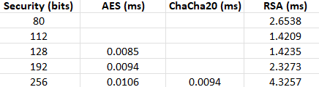

Decryption Results
RSA Decryption is far more expensive than RSA encryption and increases sharply with the larger key sizes, reaching nearly a full second at its highest bit security. In comparison, AES and ChaCha20 decryption remain extremely fast and stable. This emphasises why RSA isn’t a common approach for bulk data encryption, as others are more efficient.

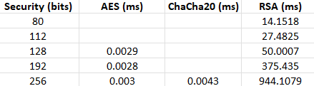

Digital Signing Results
As shown in the graph, digital signature generation becomes more expensive the higher the security level. RSA shows the steepest increase, especially past 128-bit security. DSA remains at a moderate rate overall, and ECC provides the best established performance by producing signatures in under 2 milliseconds, even at its full bit security capability.

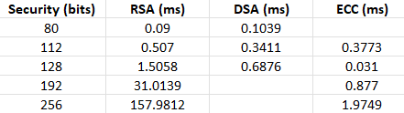

Verification Results
Verification is typically much cheaper than signing for all algorithms. RSA verification is particularly fast due to the small public exponent, and it scales well with each key size. DSA verification is slower but still efficient, while ECC verification increases with curve size but stays below 2 milliseconds, making it the most balanced and efficient option.

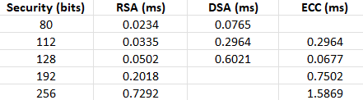

Conclusion
The results from this experiment lined up with expectations of how these algorithms would typically run. Symmetric encryption (AES & ChaCha20) was consistently the fastest, completing encryption and decryption almost instantly. This aligns with the expected performance as symmetric cyphers are designed for high-end data processing.
The asymmetric algorithms also ran as expected. RSA performance dropped significantly as the key size increased, particularly for key generation and decryption. I noticed that RSA 256-bit security required significantly more time to complete than the lower key sizes, which reflects the increase in generation time. DSA also slowed down with the increase in key size, but not as dramatically. ECC remained the most efficient across all tests, especially during key generation and digital signing, which completed in under 2 milliseconds even at the highest bit security level. This confirms why ECC would typically be used in modern practices, where performance speed is essential to the functionality.
RSA encryption times didn’t increase noticeably with larger key sizes, which might seem misleading, but this is cause the public exponent is kept small to keep encryption fast even at the higher bit security levels. The results of the ECC digital signing and verification tests didn’t follow the typical pattern of how the rest of the experiments reacted to the increase in key sizes. ECC 128-bit security seemed to perform noticeably faster than 112-bit security, which seemed unusual, but after further research, I found that some curves react differently depending on the applied optimisations within the cryptography library.
Overall, there were no major observations that contradicted expectations. The verified data stayed consistent with the typical performance behaviour of cryptographic profiles.
- Symmetric algorithms are identified to be the fastest.
- ECC offers the best possible efficiency among asymmetric.
- RSA slows down significantly each time the key size increases.
- ChaCha20 is continuously the fastest algorithm when available.
